Changing a Member's Years In Program (Co Mgr) - 6/8/23
If a member's Years in Program (formerly known as Years in 4-H) is incorrect, follow these steps to correct the field:
1. Click on the Member's record from the Member Search.
2. Click on the Enrollment Tab within the member's record.
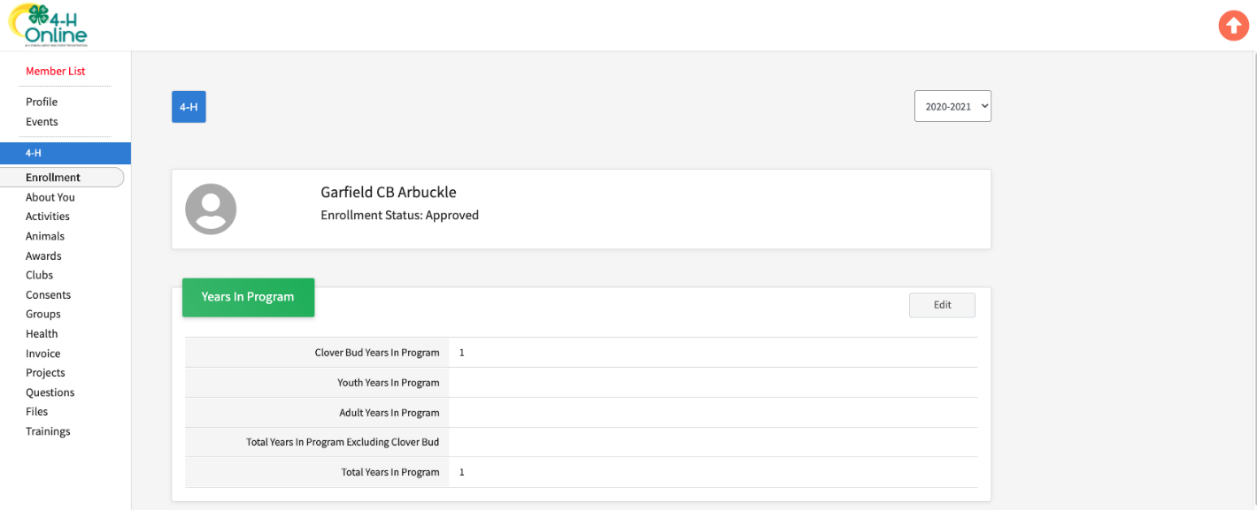
3. Select to Edit the Years in Program.
4. Managers can edit the "4-H years outside of 4-H Online" field. Note that for Extension Online, the headers are program-specific.
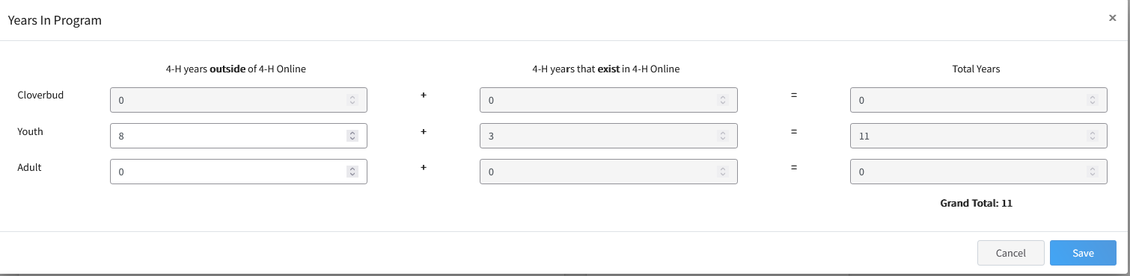

NOTE: Managers cannot change the years that exist in 4-H Online or Extension Online - as that is calculated based on the approved enrollments in the system. When a new profile is created, the family/manager can enter the Years in Program before the state program started using 4-H Online/Extension Online - the system takes that number and adds the number of years with approved enrollments to reach the total years.
For 4-H Online, the system also calculates how many years as Cloverbud, youth and adult based on previous enrollments and the state's (or program's) Age/Grade Division settings.

